HD 134987

HD 134987 is a 1.07 M☉, G4V star1. The CH survey reported a GP (HD 134987b) signal with a period of 258.18 days, a minimum mass of 1.56 MJup and an eccentricity 0.23 and a LPGP (HD 134987c) signal with a period of 5000 days, a minimum mass of 0.8 MJup and an eccentricity of 0.11. Then, based on 113 RV HIRES data obtained between 1997 and 2019, the CL survey found HD 134987b with properties close to those of the CH survey and HD 134987c with a period of days, a minimum mass of MJup and an eccentricity of .

In the present study, in addition to the CL survey’s dataset, 63 RV AAT measurements obtained between 1998 and 2009 and 57 RV measurements obtained with HARPS between 2004 and 2016 were used. DPASS and MCMC (1000 walkers and 300000 iterations) were used to fit the data. The properties found for planets b and c reported in the CL survey were within the error bars associated with the values found in the present analysis.

The fits are shown in Fig 1, and the corner plot in Fig 2, and the results summarized in Table 1.

Conclusion: The properties of HD 134987c found in the CH survey are not confirmed but those found in the CL survey are confirmed.

Figure 1: Left: fit of the HD 134987 RV with DPASS. Red - AAT, green - Hir94, blue - Hir04, cyan - H03, purple - H15. The blue curve shows the best fit. Right: fit of the HD 134987 RV using MCMC. The black curve shows the best fit. The colorbar corresponds to the log-likelihood of the fits. The gray dotted line indicates the end of the CH survey.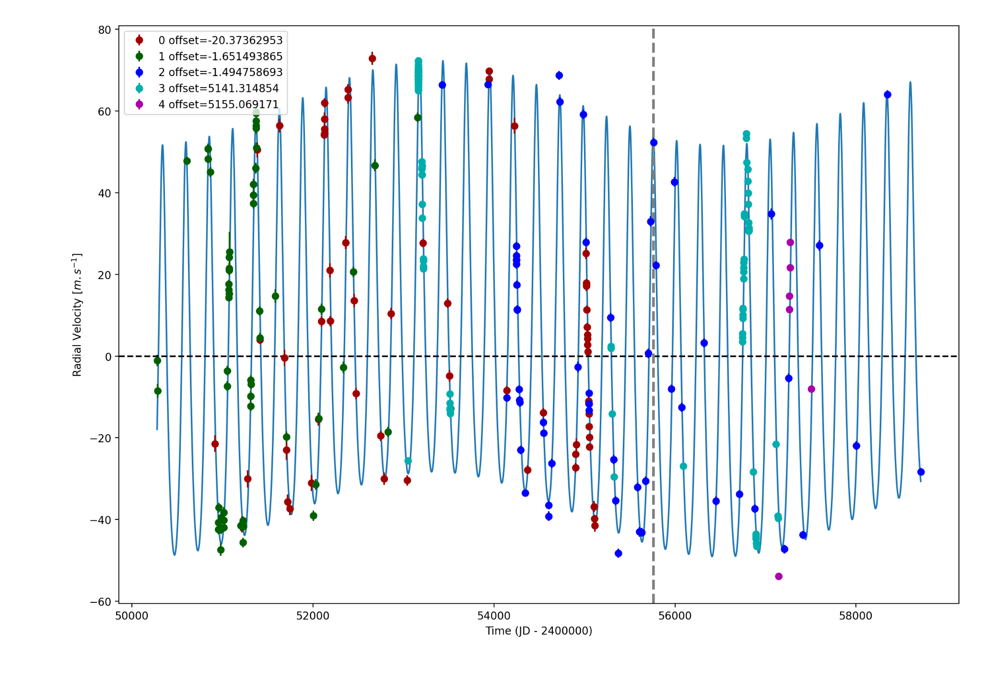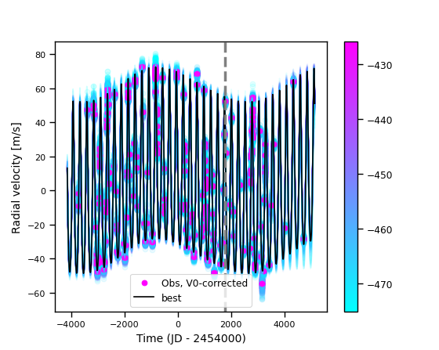

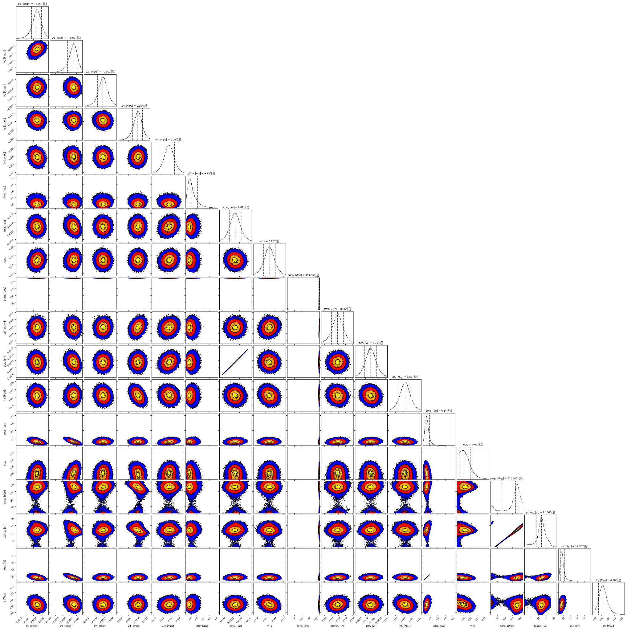

Figure 2: Corner plot of posteriors for the two-planets model MCMC fit of HD 134987 RV data.

| Parameter | Priors | | Posteriors | | CH/CL survey |
| --- | --- | --- | --- | --- | --- |
|  | DPASS | MCMC | DPASS | MCMC |  |
| *a* (au) | b: [0,5]  c: [0,30] | b: [0.5,1]  c: [1,65] | b = 0.81  c = 6.8 | b = 0.81 ± 0.01  c = | CH survey:  b = 0.8  c = 5.9  CL survey:  b = 0.817 ± 0.012  c = |
| Msin(i) (MJup) | b: [0,300]  c: [0:100] | b: [1.5,2]  c: [0.5,10] | b = 1.6  c = 0.99 | b = 1.61 ± 0.02  c = | CH survey:  b = 1.56  c = 0.8  CL survey:  b = 1.623 ± 0.049  c = |
| Eccentricity | b: [0,0.95]  c: [0,0.95] | b: [0,0.4]  c: [0,0.8] | b = 0.23  c = 0.0 | b = 0.23 ± 0.01  c < 0.17 | CH survey:  b = 0.23  c = 0.11  CL survey:  b =  c = |
| Instrumentals offsets (km/s) | [-60,60] | AAT: [-1,1]  Hir94: [-1,1]  Hir04: [-1,1]  H03: [4,6]  H15: [4,6] | AAT: -0.020  Hir94: -0.002  Hir04: -0.002  H03: 5.141  H15: 5.155 | AAT: -0.021 ± 0.001  Hir94: -0.002 ± 0.001  Hir04: -0.001± 0.001  H03: 0.141± 0.001  H15: 0.156 ± 0.002 |  |
| Stellar jitter (m/s) | [0,40] | [0,40] | 3.7 |  |  |
| Argument of periastron (°) | b: [0,360]  c: [0,360] | b: [0,360]  c: [0,360] | b = 355  c = 87 | b = 354± 3  c = 121 – 320 |  |
| Phase | b: [0,1]  c: [0,1] | b: [0,1]  c: [0,1] | b = 0.93  c = 0.74 | b = 0.79± 0.01  c = 0.49 – 0.83 |  |

Table 1: HD 134987. Summary of priors and posteriors obtained with DPASS and MCMC compared to the results obtained by the CH and the CL surveys.

References

1. Jones, H. et al. A long-period planet orbiting a nearby Sun-like star. *Mon. Not. R. Astron. Soc.* 403, 1703-1713 (2010).